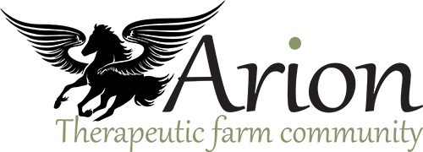
ANIMAL INTERACTIONS
WAIVER AND RELEASE OF LIABILITY

In consideration of being allowed to participate in any way in Arion Therapeutic Farm Community Contribution Company Ltd.’s Animal Interactions, or any other programs, related events and activities, the undersigned acknowledges, appreciates, and agrees that:

1. The risk of injury from the activities involved in this program is significant, including the potential for permanent paralysis and death, and while particular rules, equipment, and personal discipline may reduce this risk, the risk of serious injury does exist; and,

2. I KNOWINGLY AND FREELY ASSUME ALL SUCH RISKS, both known and unknown, EVEN IF ARISING FROM THE NEGLIGENCE OF THE RELEASEES or others, and assume full responsibility for my participation; and,

3. I willingly agree to comply with the stated and customary terms and conditions for participation. If however I observe any unusual significant hazard during my presence or participation, I will remove myself from participation and bring such to the attention of the nearest official immediately; and,

4. I, for myself and on behalf of my heirs, assigns, personal representatives and next of kin, HEREBY RELEASE AND HOLD HARMLESS Arion Therapeutic Farm CCC Ltd; their officers, officials, agents and/or employees, other participants, sponsoring agencies, sponsors, advertisers, and, if applicable, owners and lessors of premises used to conduct the event (“Releasees”), WITH RESPECT TO ANY AND ALL INJURY, DISABILITY, DEATH, or loss or damage to person or property, WHETHER CAUSED BY THE NEGLIGENCE OF THE RELEASEES OR OTHERWISE.

I HAVE READ THIS RELEASE OF LIABILITY AND ASSUMPTION OF RISK AGREEMENT, FULLY UNDERSTAND ITS TERMS, UNDERSTAND THAT I HAVE GIVEN UP SUBSTANTIAL RIGHTS BY SIGNING IT, AND SIGN IT FREELY AND VOLUNTARILY WITHOUT ANY INDUCEMENT.

X __________________________________________
PARTICIPANT’S SIGNATURE

X __________________________________________ Date Signed: _______________________
WITNESS

FOR PARTICIPANTS OF MINORITY AGE
(UNDER AGE 18 AT TIME OF REGISTRATION)

This is to certify that I, as parent/guardian with legal responsibility for this participant, do consent and agree to his/her release as provided above of all the Releasees, and, for myself, my heirs, assigns, and next of kin, I release and agree to indemnify the Releasees from any and all liabilities incident to my minor child’s involvement or participation in these programs as provided above.

X _________________________________________ ___________________________________
PARENT/GUARDIAN’S SIGNATURE EMERGENCY PHONE NUMBER

X ________________________________________ ___________________________________
WITNESS

